COMP 7500 Lecture 26: Disk Scheduling (Cont.)
: >85%, : 70-85%, : 55-70%, : 40-55%, : < 40%

Exercise 1 (MS Forms): Given a disk queue (2, 10, 7, 1) and the disk head’s starting track of 8, what is the total disk head movement of FCFS?
A) 23 B) 18 C) 26 D) 35

Exercise 2 (MS Forms): Given a disk queue (2, 10, 7, 1) and the disk head’s starting track of 8, what is the total disk head movement of SSTF?
A) 10 B) 13 C) 18 D) 21

Exercise 3 (MS Forms): Which one of the following statements about SSTF is incorrect?
A) It provides increased throughput
B) It provides less average response time and waiting time.
C) It provides low variance in response time and waiting time.
D) It reduces the total seek time

Exercise 4 (MS Forms): Given a disk queue (2, 10, 7, 1) and the disk head’s starting track of 8, what is the total disk head movement of SCAN? Assumptions: (1) the disk head initially moves towards 10 and (2) cylinders range from 1 to 10.
A) 6 B) 11 C) 17 D) 20

Exercise 5 (MS Forms): Which one of the following statements about SCAN is incorrect?
A) It is simple, easy to understand and implement.
B) It provides low variance in response time and waiting time.
C) It causes the head to move till the end of the disk even if there are no requests to be serviced.
D) It might lead to starvation.

Exercise 6: Given a disk queue (2, 10, 7, 1) and the disk head’s starting track of 8, what is the total disk head movement of C-SCAN? Assumptions: (1) the disk head initially moves towards 10 and (2) cylinders range from 1 to 10.
A) 6 B) 11 C) 17 D) 20

Exercise 7 (Group Discussion. 1.5 Min): What are pros and cons of C-SCAN?
Advantages:
- The waiting time for the cylinders just visited by the head is _____ as compared to the SCAN Algorithm.
- It provides ______ waiting time.
- It provides ______ response time.
Disadvantages
- It causes _____ seek movements as compared to SCAN Algorithm.
- It causes the head to move till the end of the disk even if ____________________________.

Exercise 8.1: Please observe this example. Can you distinguish the differences between the SCAN and LOOK algorithms?
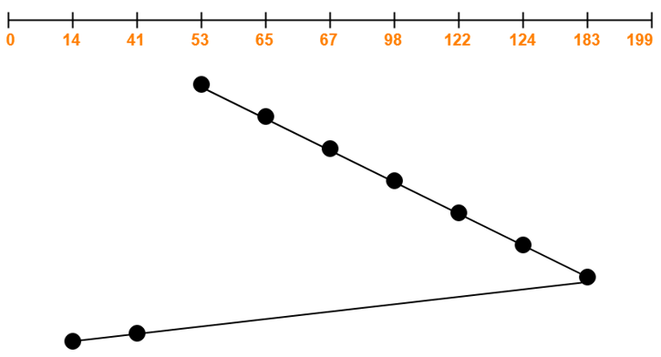

Exercise 8.2: What’s the total disk head movement of LOOK?

Exercise 9: Can you describe the C-LOOK (a.k.a., Circular-LOOK) algorithms?

